**BIBD Mini Project**

**Installing MongoDB:**

1. Run the setup file and click on **Next**.

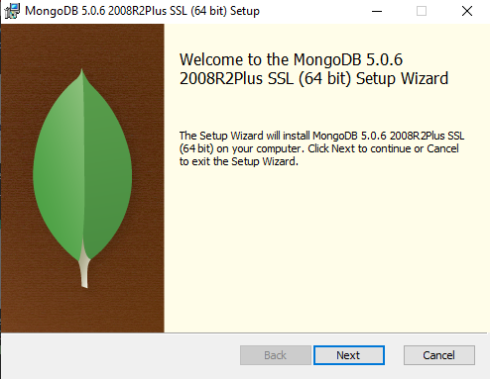

1. **Accept the terms in the License Agreement** and then click on **Next**.

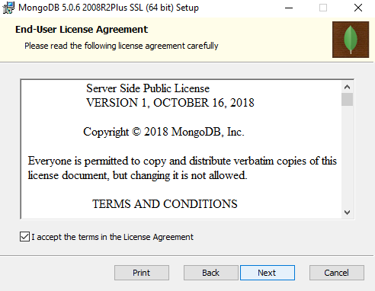

1. Click on **Complete** setup type.

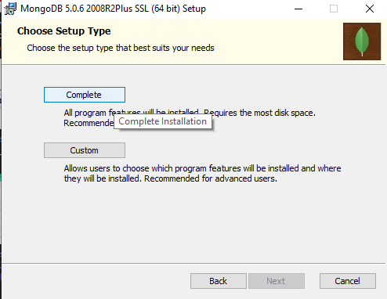

1. Don’t change any settings in Service Configuration just click on **Next**.

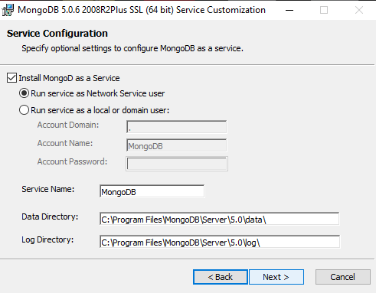

1. If you want MongoDB Compass let the check box be selected and click on **Next** or else uncheck the check box and then click on **Next**.

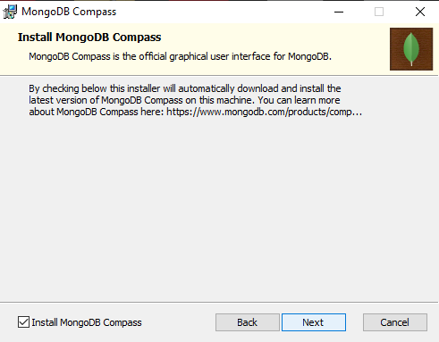

1. Click on **Install** to install MongoDB on your system.

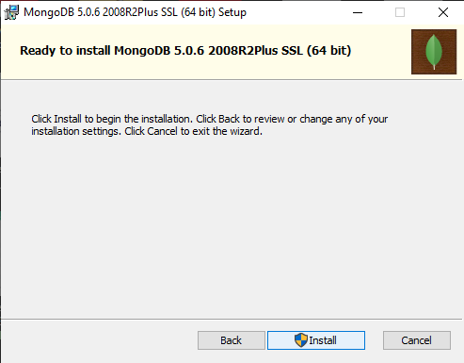

1. After installation is finished, click on **Finish** to exit the Setup of MonogDB.

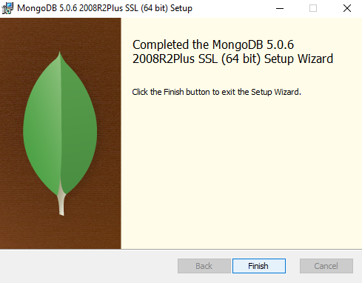

1. Now go to File Explorer, and go to Local Disk C and create a new folder “data”.

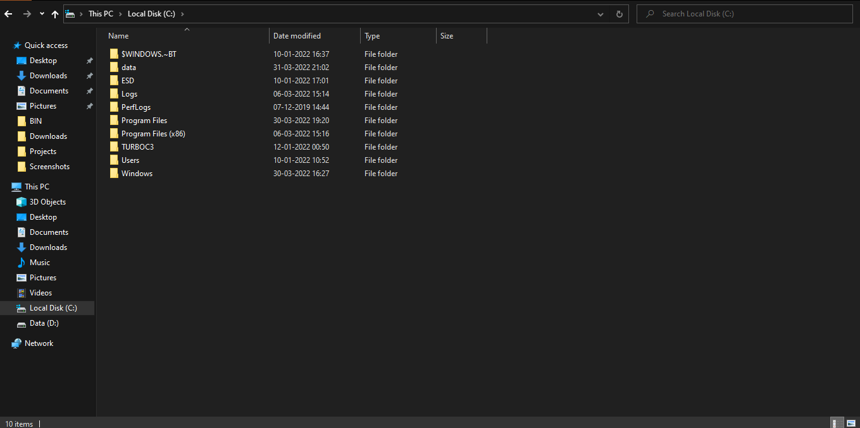

1. Now create a new folder “db” inside data folder.

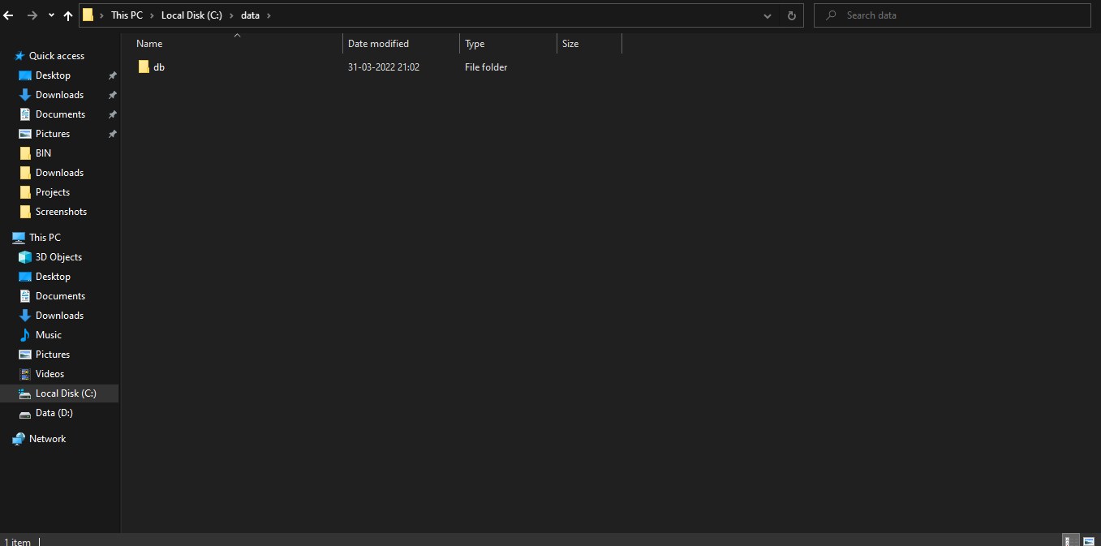

**Code:**

SERVER:

cd C:\Program Files\MongoDB\Server\5.0\bin

mongod

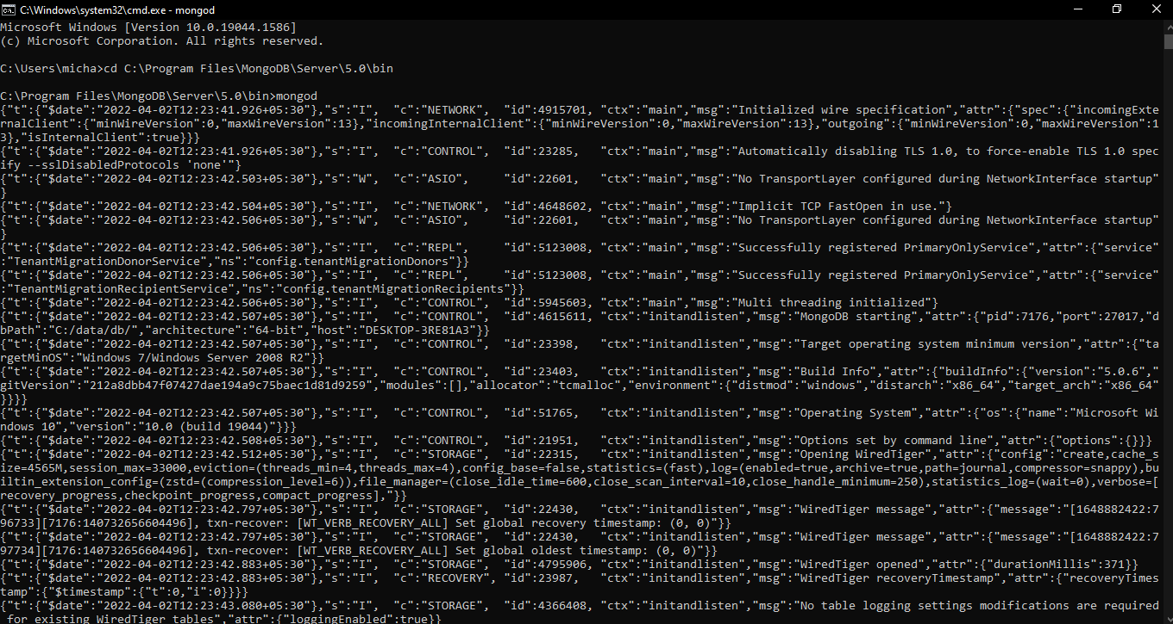

CLIENT:

cd C:\Program Files\MongoDB\Server\5.0\bin

mongo

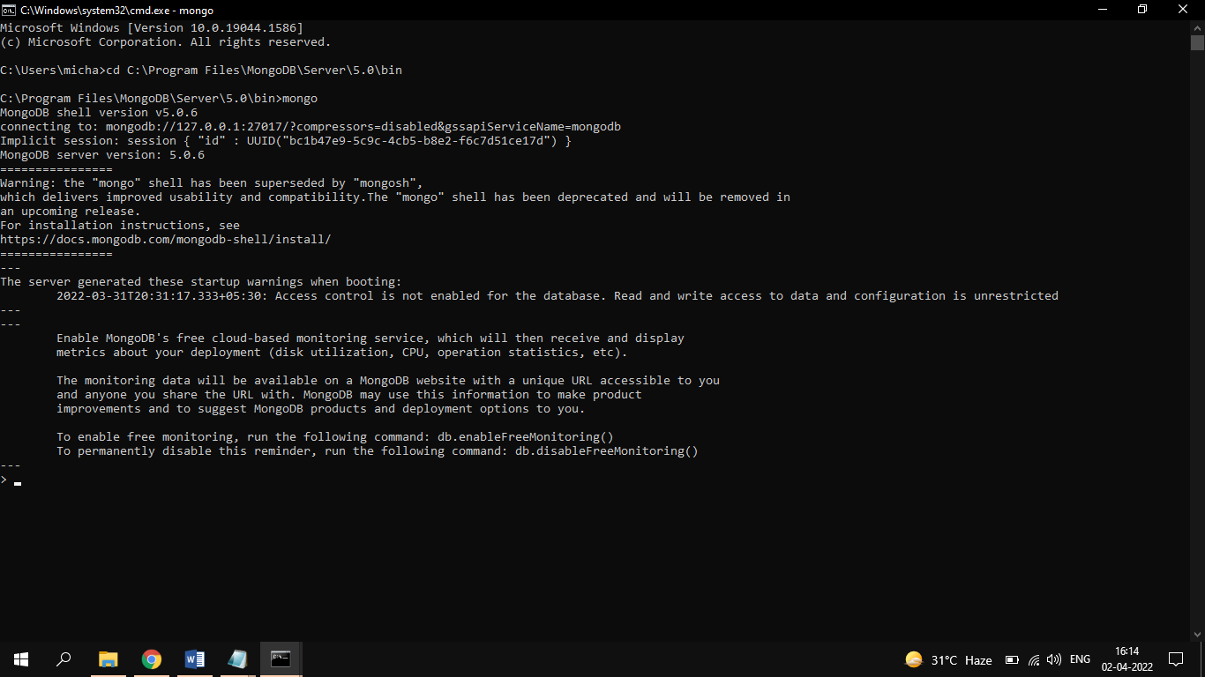

show dbs

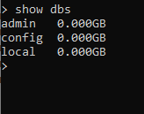

use Cars



db.carsdata.insertOne({srno: 01, name: "Maruti Suzuki", price: 150000, type: "Car"})

db.carsdata.find().pretty()

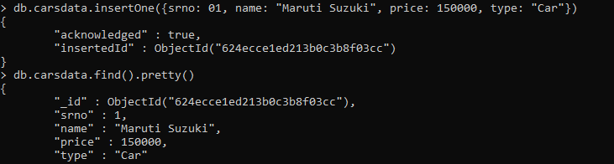

db.carsdata.insertMany([

{srno: 02, name: "BMW", price: 7500000, type: "SUV"},

{srno: 03,name: "Toyota", price: 1000000, type: "SUV"},

{srno: 04,name: "Skoda", price: 2500000, type: "Car"},

{srno: 05,name: "Hyundai", price: 500000, type: "Car"},

{srno: 06,name: "Volkswagen", price: 800000, type: "SUV"},

{srno: 07,name: "Mercedes", price: 5000000, type: "Car"}

])

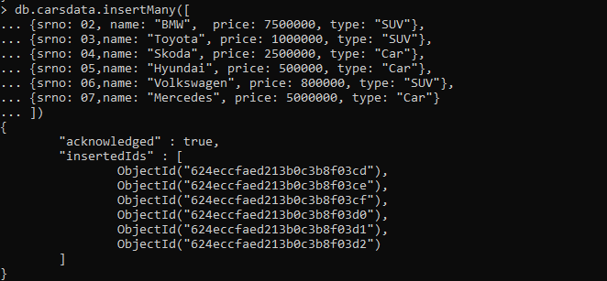

db.carsdata.find().pretty()

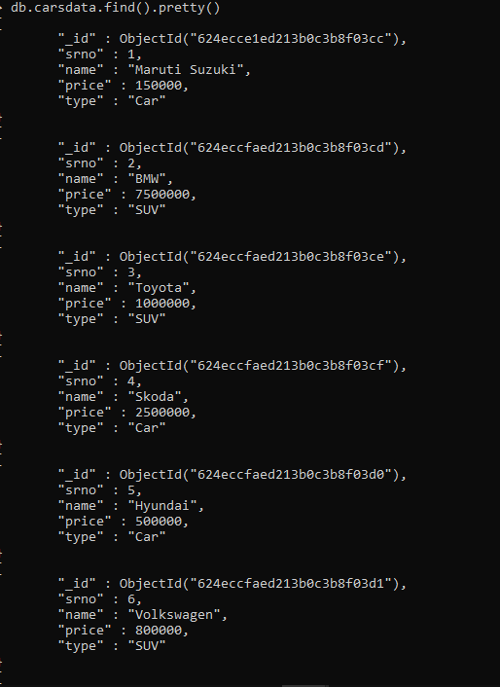

db.carsdata.updateOne({name: "BMW"}, {$set:{price: 8000000}})

db.carsdata.find().pretty()

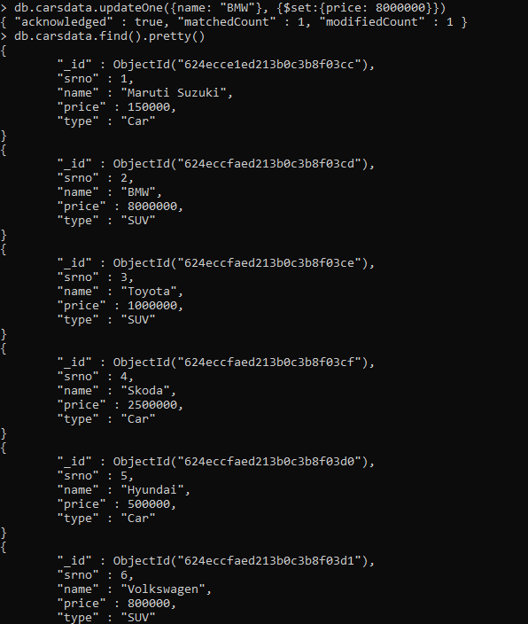

db.carsdata.updateMany({type:"SUV"}, {$set: {price: 1500000}})

db.carsdata.find().pretty()

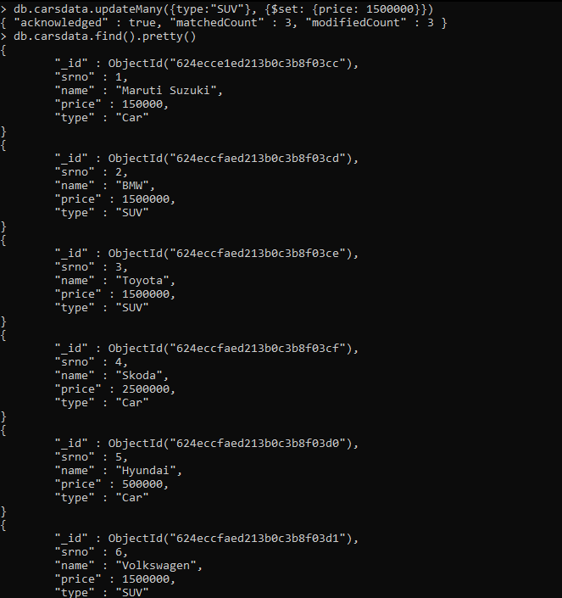

db.carsdata.replaceOne({name: "Maruti Suzuki"}, {name: "Maruti"})

db.carsdata.find().pretty()

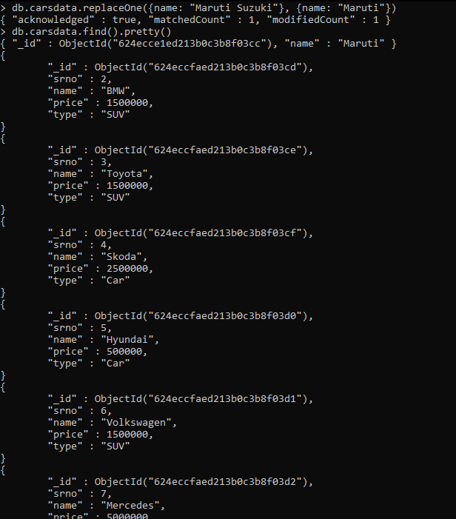

db.carsdata.deleteOne({"price":500000})

db.carsdata.find().pretty()

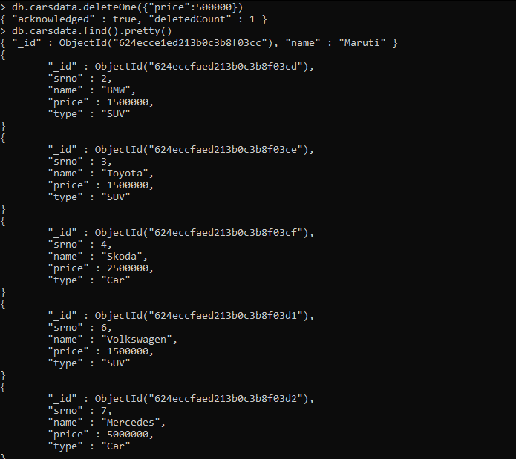

db.carsdata.deleteMany({type:"Car"})

db.carsdata.find().pretty()

